|  |
| --- |
| **Rafi Bin Abedin**  H# 21, R- 04, B-F, Eastern Housing, Mirpur,  Dhaka-1216  C:\Users\user\Pictures\Saved Pictures\OIP68VT0086.jpgrafiabedin2@gmail.com  C:\Users\user\Pictures\Saved Pictures\cell-clipart-logo-7.jpg01686968770 |

**PROFESSIONAL SUMMARY**

An effective, ambitious, discipline, energetic CRE, Marketing & Sales Executive is a quick learner, hard-worker & expert in combining knowledge experience.

**SKILLS**

**Microsoft Office Tools Google Digital Marketer Microsoft E-Tech Developer**

**Educational Researcher Co-coordinator Energetic & Leadership**

**EXPERIENCE:**

Sales & Marketing Executive

**Green Bengal Engineering Ltd**

Since 2016-2018

Mirpur,Dhaka

Customer Relationship & Administrative Executive.

**Team EXIO**

Mirpur-11, Dhaka

At Present

**IT Reach Ltd**

Gulshan-1, Dhaka

Telemarketing & Digital Marketing Executive

Since 2019-2020

Telesales Executive & Sales Representative

**Urban Utilities & Associates Ltd.**

Uttara, Dhaka

**EDUCATION BACKGROUND**

***B.S.Sc ( Hon’s)***

*National University*

*From Adamjee Can’t College*

*CGPA- 2.94*

***Achievement***

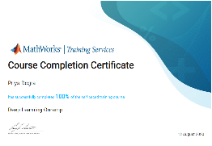 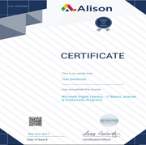

***I declare hereby that all information provided is accurate and up to date.***

**Reference**

* ***Mahmudur Rahman***

***Managing Director***

***Green Bengal Engineering Ltd.***

***Contact*** *- 01971217375*

*Dhaka*

* ***Md.Ronee Hossain***

***Senior Marketing Executive***

***Smart Electronics & Solution***

**MOBLIE:** 01708488762